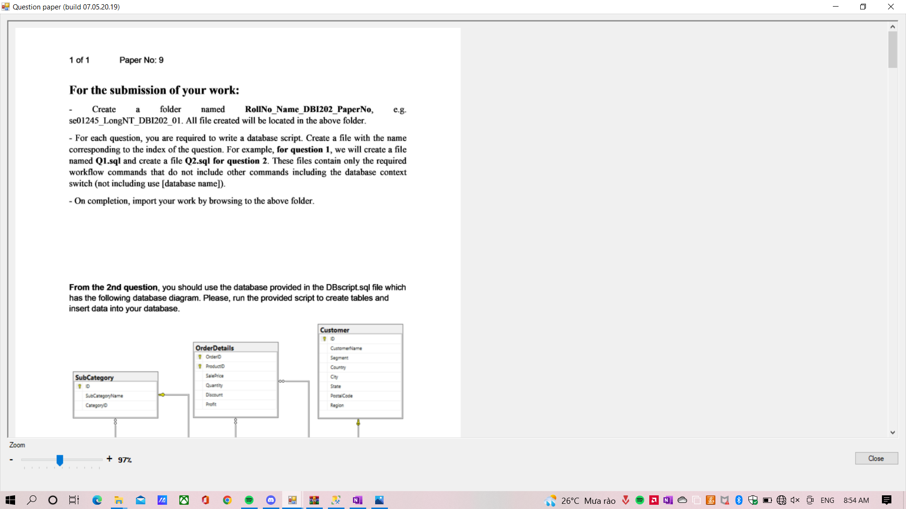

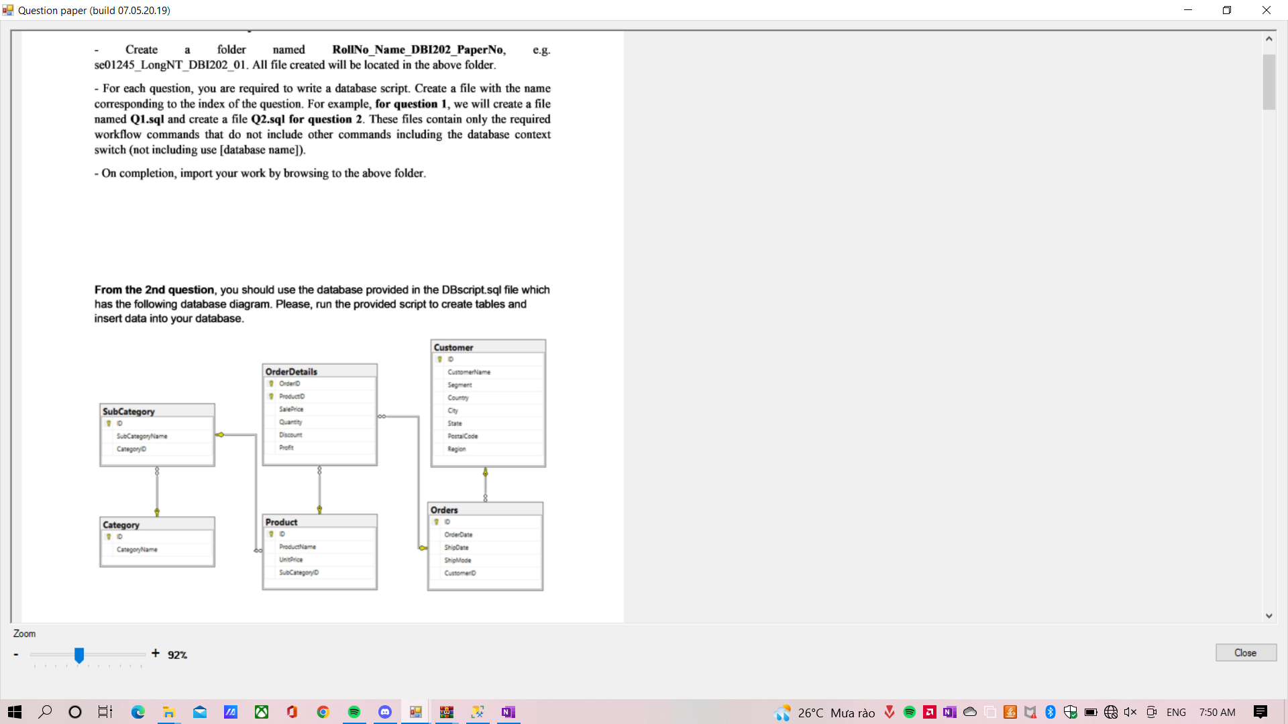

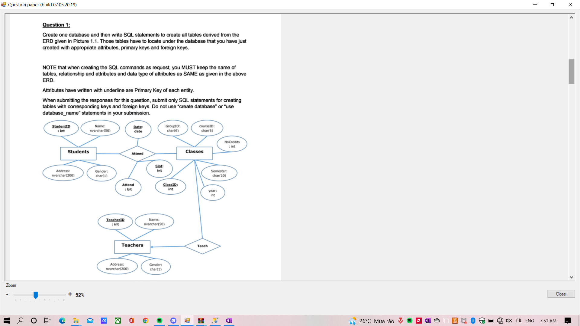

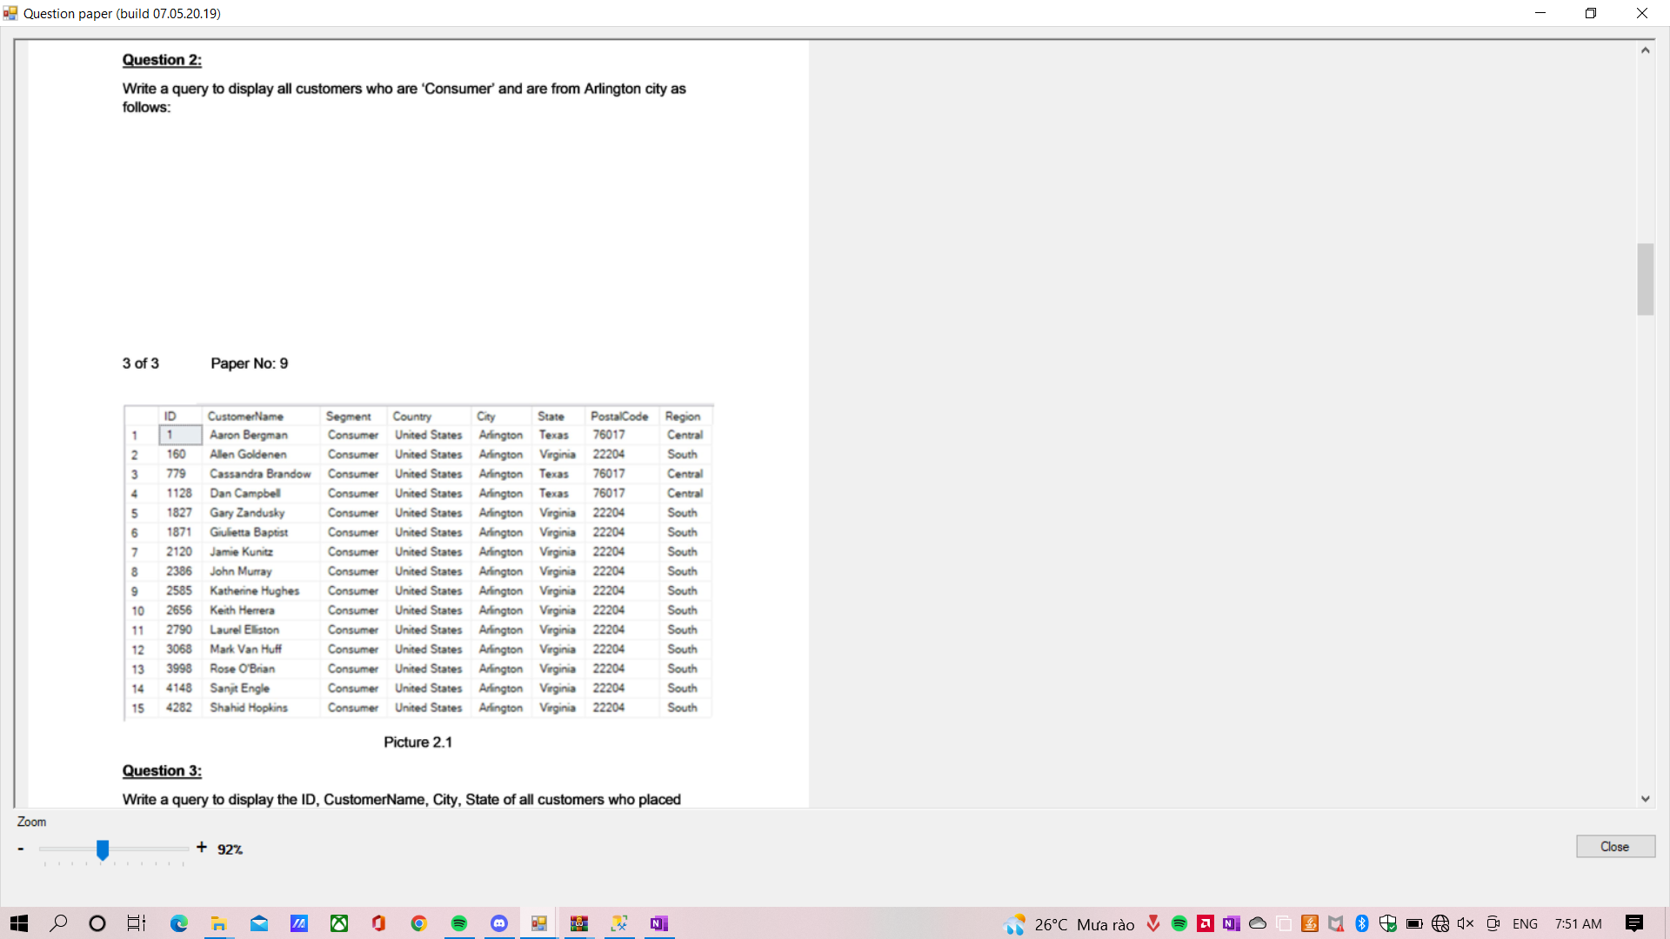

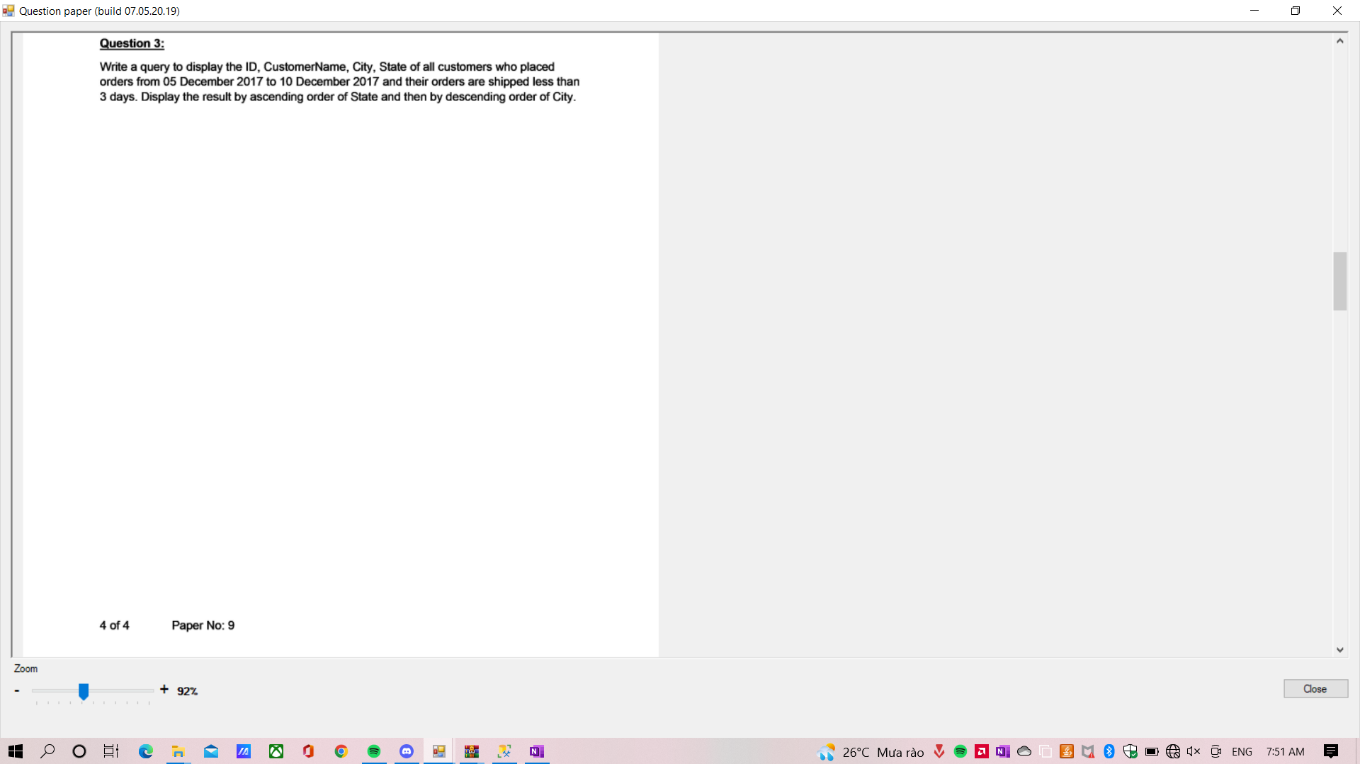

paper (build 0705.2019) 
х 
2 
з 
4 
7 
8 
9 
12 
13 
14 
3405 
2940 
862 
1273 
2867 
1333 
4291 
332 
733 
270' 
486 
3604 
Нате; Рже 
Вуа 
F0•st« 
Chis Сан 
Th—pson 
Sh.agi•i 
L•tchfvd 
Anthony 
СВ Weiss 
Кеп 
Pet«man 
ау 
Sto&ton 
l-.ud«d" 
baha 
T±do 
Rhode 
Тех“ 
РК1ите 3.1 
The Arn«mt 0f exh рготд ал Ьу -DBcourt). 
Те TOWAmount each Sum о! ttp Amount аш 70duct the огфг. Wrtte а 
+ 92Х 
Р 
О 
о 
е 
26'С Миа Ы 
В О (х ENG 
7:51 АМ 

Question paper (build 0705.2019) 
The Ammant Of each in an by -Discourt). 
The TOWAmount of each order is the sum of the Amount of all prrxduct the Write a 
query to display OrderlD, OrcErDate, TotalArnount of an orders having ToWAnount weater 
than by crder ci TotalArrnunt follows: 
5015 
2 
3 
4 
s 
6 
Totaßnount 
23661.228 
18336.74 
14052.48 
13716.458 
10539.896 
10499.97 
P 
O 
No: 9 
OrderlO 
CA-2014-US317 
CA-2016-118689 
CA-2017-1401S1 
CA-2017-127180 
CA-2014.139892 
CA-2017.166709 
u 
2014-03-18 
2016-10-02 000000.000 
2017-03-23 000000.000 
2017-10-22 000000.000 
2014-09-08 000000.000 
2017-11.17 
o 
o 
266C Mua råo 
O O @ ENG 
7:51 AM 

! Question paper (build 07P5.2d19 ) 
12 
13 
CA • 2014 • 14 17 
US • 2017 168116 
20149 25 : • 8.000 
20174 : • 8.000 
3319.29 
3167 , 42 
Fil w eor r day t la ord fo | : 
0 
: 0 : • : 00 : 080 
2013-0103 : 08t0 
Cu 丨 Name d | 吅 「 ord $ 
( N | 0 ℃ rd $ ) 30 11 $ * h02y0 $ tr m 
1 
2 
636 
2655 
339 
P r : 9 
CustanerName 
Keh Dawk•ns 
Steven Roe 
N , 0 d “ , 
3 
3 
P 
0 
0 
€ 
0 
, 26 ℃ Mua 0 
O ta 0 ENG 
7 : 51 AM 

paper (build 0705.2019) 
DispIay 5 70-ducts the ипа 5 70ducts with smazt prms 
х 
2 
в 
7 
9 
477 
476 
326 
Sy•s— ЕХ9О 
Симу САХ 30 Р—м« 
СиЫу Си“Х ЗО Оси“ р-тм 
ОК 
7GB 
4,70 
РК1ите 7.1 
22'9.9926 
' S72.0233 
0.ssu 
0.34S 
14 
14 
4 
4 
МЙе а stor«j TotaArmunt to ttw t)taI amount ап with 
0rdedD (пуысћаг(255)) is its 'п;дЛ parameter TMatArT0unt (fbat) В tt» 0uVut 
pararTEter. Note that пте Amount 0' еасћ product ап омет is cak:ulate as 
1 -t)iscount) ам TotalArrmmt of еасћ омег ttw sum аи 
АтоипВ of аи products h те огам. 
For ехитр'е. we execute the соф, те result should 377.97: 
dedue fbat 
ехес тошимошм СА-2014-тоое•. оицда 
print@t 
Create а 1пшВфСаШдогу whk:h Ьу insert statermnt the 
SubCategory table. The trigget МИ display Те SubCatepyName and the CategoryNarre 
the яф--са•гЮ$ wfjch BJSt Ьееп Ву 6sert 
+ 92Х 
Р 
О 
о 
е 
26'С Миа Ы 
В О (х ENG 
7:51 АМ 

Question paper (build 0705.2019) 
a which w" by an insert inb the 
SubCategory table. The trigger wil display the SubCatepryName and the CategoryNarTE 
the which have Bast been inserted by the nsert 
For wtm run: 
insert hto CatevytD) 
('BOdS,2) 
The result as 
I 
CategoryName 
Furniture 
Beds 
Picture 9.1 
Insert me hformaW1: 
• A •Sports' inb tat* (Negory 
A 'Tennis' md a ht0 
both mese tw•o are subcategories of C&90ry 'Scx»rts• 
P 
O 
u 
o 
o 
266C Mua råo 
O O @ ENG 
7:52 AM 